Konflux Theatre’s
Anti-Bullying Week Worksheet!
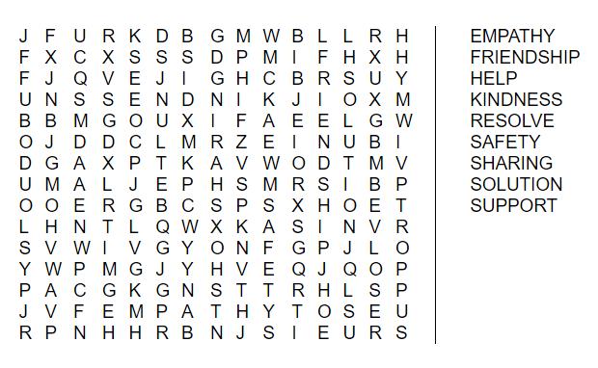

Can you find all the words hidden in the grid?

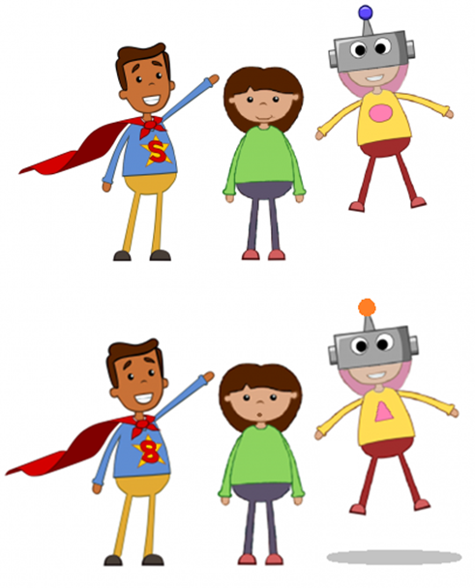
There are 5 differences between these two pictures – can you spot them all?

- Difference differe
- Difference differe
- Difference differe
- Differendifferenc
- Difference differe

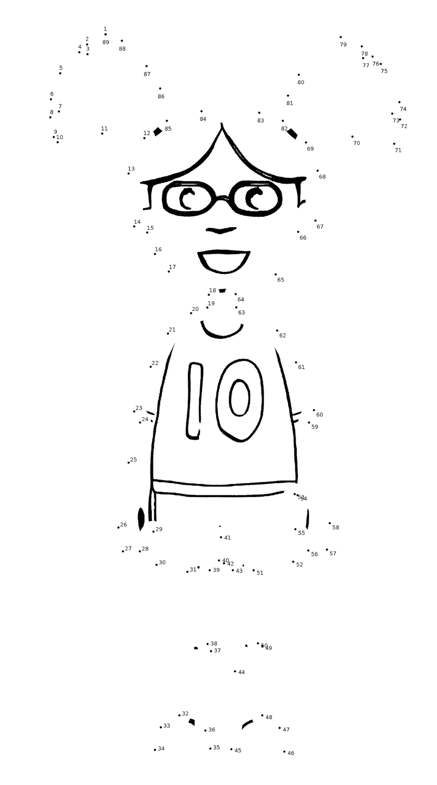
Complete the image of our Konflux Kid by connecting the dots!

